**Program Evidence of running**

**GitHub Username**

Gemma Buckland

b7010126

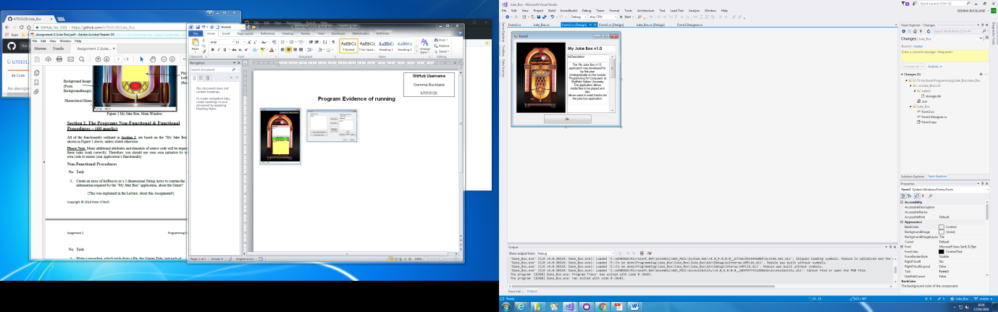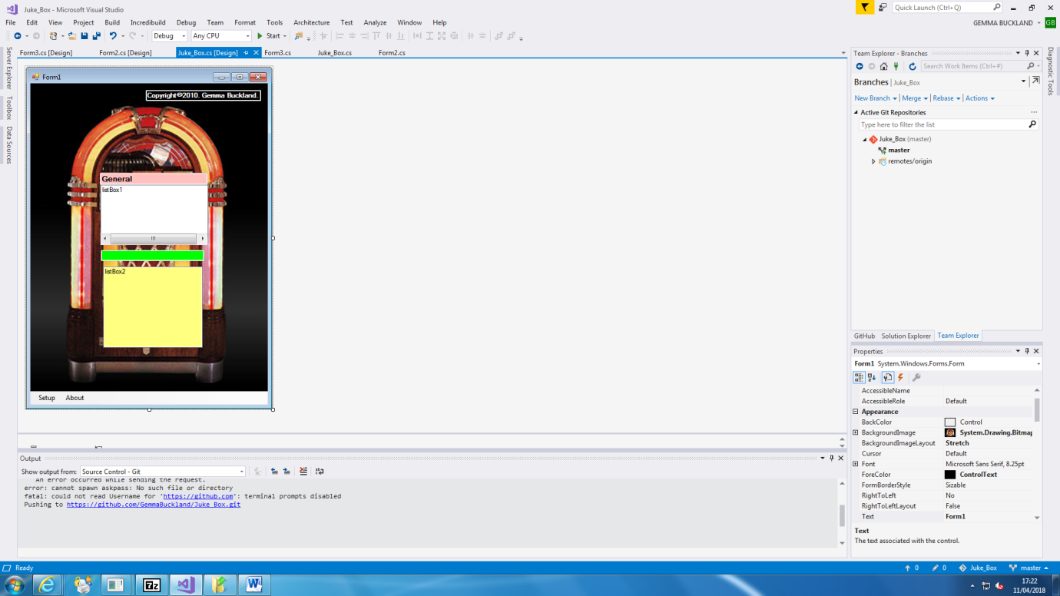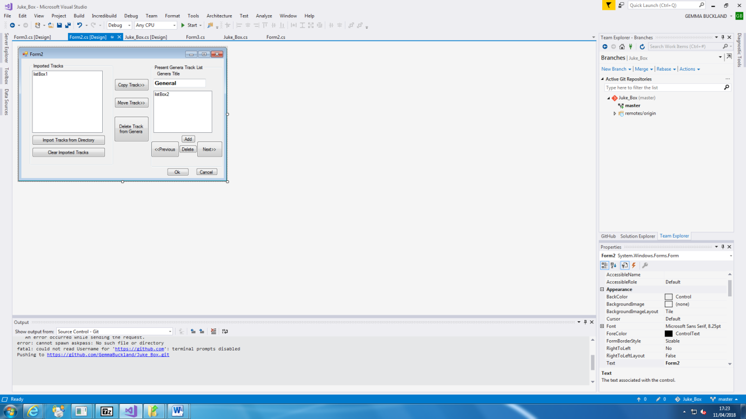

**The final working interface**

These are all the interfaces that I have created for my 'Juke Box' assignment I have changed the background image from the original interface.